**Using photoReg**

photoReg is a web api for storing images. Below is the list of the different command you can give it.

In this app you can upload images for a user and add tags which other can use to query for your images with.

Note: All commands were done using PostMan, it is suggested you do the same.

**Sign_up:**

You need to make sure you sign up an account.

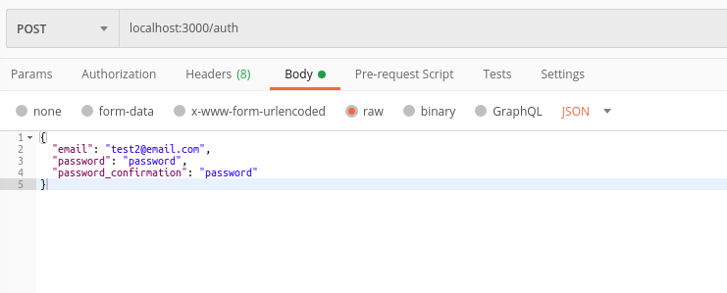

**Sign_in:**

You need to make sure you sign into your account before you do any other actions

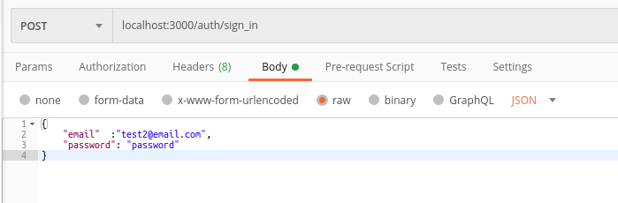

Running this command will give you three pieces of information back you will need for the rest of your requests, the uid, client, and access_token. Save these pieces of data and include them in the headers of all other calls.

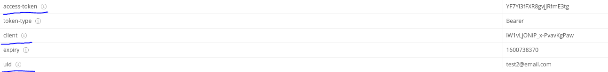

**Sign_out:**

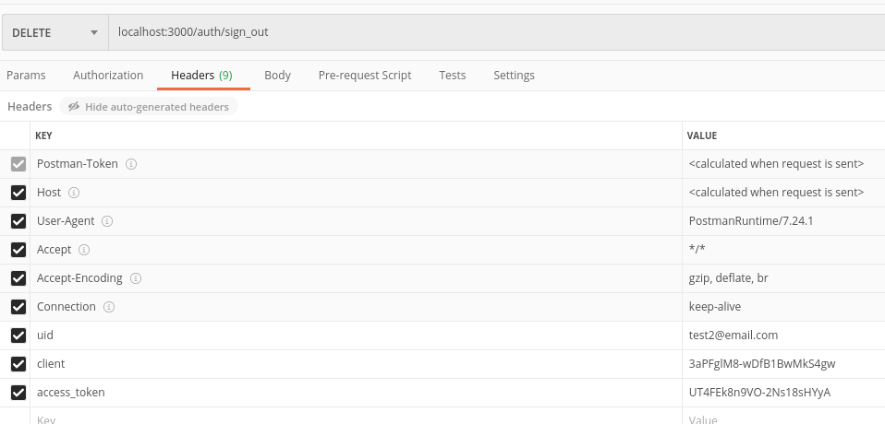

**Uploading an image:**

Make sure you select the file option when uploading the image value. You can also submit multiple tags as a list for on image.

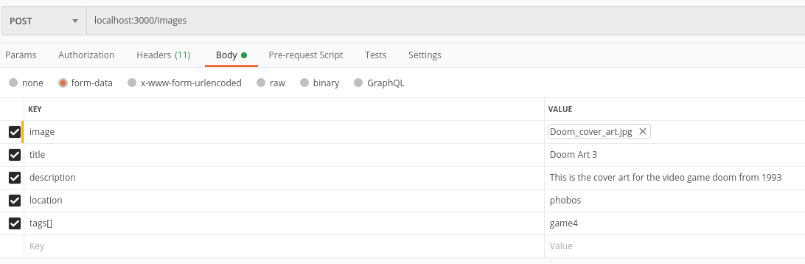

**Deleting an image:**

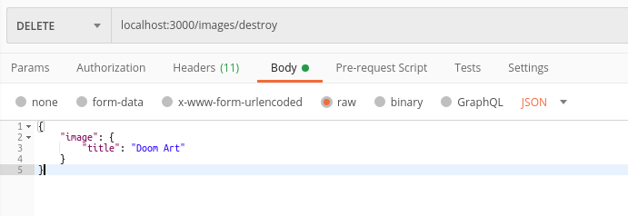

**Display the image:**

This will send a url to follow to view the image in a browser.

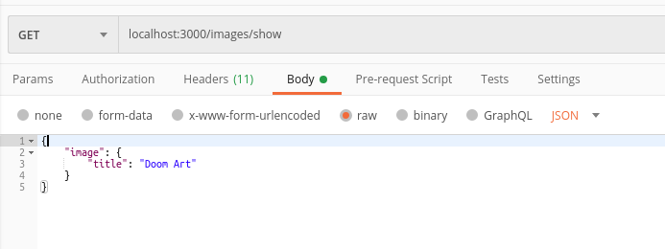

**Get info on the image you uploaded:**

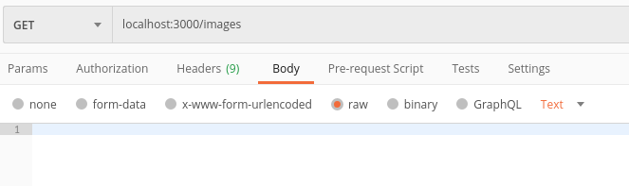

**Get images that have a certain tag:**

